Research Proposal

Understory Plant Diversity of the Ecuadorian Amazon at Different Scales and Altitudes

Roberto Román-RR

2023-11-10

# Introduction

The alpha and beta diversity of vascular plants has been analyzed in different gradients.

(Dell *et al.* 2019 a; Dell *et al.* 2019 (b)

# Objectives/Hypotheses

## Objectives

General: To evaluate the association between the scale of analysis and the diversity of understory plants in the Ecuadorian Amazon in different altitudinal ranges.

* Control the effect of spatial autocorrelation on understory plant diversity by defining geographically distinctive parcel groups.
* Estimate the average alpha and beta diversity of understory plants in different altitudinal ranges.
* Determine the average fluctuation of alpha and beta diversity at different scales of analysis.
* To contrast the effect of the analysis scale on the alpha and beta diversity of understory plants in different altitudinal ranges.

## Hypothesis

* An increase in the scale of analysis is associated with an increase in alpha diversity and a decrease in beta diversity of understory vascular plants.
* The rates of change in alpha and beta vascular plant diversity as a function of the scale of analysis are more pronounced at high elevations, in contrast to low elevations, where the change in alpha and beta diversity is more discrete.

# Methodology

The data to be used in this work correspond to a database of diversity and ecological interactions between understory plants and insects of the Order Lepidoptera. The main objective of the research was to evaluate the ecological interactions between these groups (For a detailed description of the methods used in the field see Dyer 2005, etc.). The botanical data correspond to the census of trees, shrubs and herbs of understory up to 10 m high from 637 plots of 5x5 m, located in the lower and upper Amazon of Ecuador. In the present work, the botanical data from this database will be used for the evaluation of the hypotheses proposed.

These data will allow us to evaluate the effect of the analysis scale on alpha and beta diversity. In this context, the present research uses botanical data observed in the field over a long time range, so it corresponds to a retrospective longitudinal observational analytical study.

## Area of Study

The study area is located in the upper and lower Amazon of Ecuador, in the province of Napo, between 200 and 4500 meters above sea level (848185.50, 9934528.14 UTM WGS84 17S). It has an area of 9300 km2, encompassing the vegetation formations of lowland evergreen forests, piedmont, low montanes, montanes, and páramo.

## Methodological design

The dependent or response variables used in this research will be alpha and beta diversity, expressed in the different diversity indices available, in which the Shannon, Simpson and Sorensen index stand out (see Jost 2007, etc. for details in its calculation). The independent or predictor variables will be the scale of analysis, temperature, precipitation and altitude. Climate parameters will be extracted for each parcel from the WorldClim 2.1 environmental variable rasters. The altitude will correspond to the data associated with each plot obtained in the field.

For the analysis of the data, a preliminary clustering will be carried out with the DBSCAN algorithm of the 637 available plots, depending on their geographical and altitudinal proximity. This will reduce the problems associated with spatial autocorrelation, and also control the effect of geographic distance on dependent variables. Within each distinctive group, plots will be randomly grouped according to the clustering factor or scale of analysis. The scale of analysis will be calculated as the sum of the area in m2 of the n grouped plots of group i and altitude j. Then, the flora data and associated data from the independent plots will be grouped into new, larger plots, depending on the scale of analysis. This means that a new plot of 125 m2 is a plot composed of the botanical records and associated data grouped together from three plots of 25 m2 located in group i and altitude j.

In terms of alpha diversity, the data pooled in the new plots will be used to calculate this index, while the temperature and precipitation will be calculated as the average of the n clustered plots. On the other hand, beta diversity will be calculated between pairs of new plots of each group and altitude, while temperature and precipitation will be expressed as the difference between the pairs of plots analyzed.

The procedure described allows the random obtaining of n new plots from each group and altitude. Therefore, this procedure will be performed iteratively using bootstrap to obtain multiple samples from each group and altitude at different scales of analysis, up to a maximum of 250m2.

## Statistical design

To form the geographically and altitudinally distinctive clusters, the DBSCAN unsupervised clustering algorithm will be used. To determine the effect of the scale of analysis and environmental parameters (temperature and precipitation) on alpha and beta diversity, using altitude as a covariate, generalized mixed linear models, generalized additive models, and Bayesian mixed or hierarchical models will be applied. The models with the best performance and fit to the data will be chosen, in accordance with the statistical assumptions of each model, using the AIC index for this purpose. If necessary, different transformations will be applied to the data (e.g. base logarithm 10) to improve the fit of the models and/or reduce residuals. This is in order to comply with model-specific statistical assumptions, such as homoscedasticity in the case of linear models.

The results obtained will be summarized in suitable tables and graphs, emphasizing the main findings of this research. All data debugging, handling, analysis and reporting processes will be carried out in the statistical programming software and environment R version 4.3.2 (R Core Group 2023).

# Expected results

Regarding alpha diversity, a linear increase is expected at a larger scale of analysis, until an asymptote is reached at a certain scale of analysis, similar to the sigmoidal curves seen in species accumulation models such as jacknife. However, it is expected that the effect of the analysis scale will depend on the altitudinal range (Figure **1**).

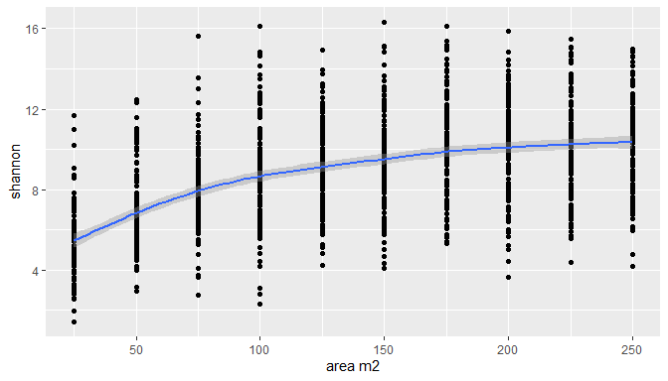

**Figure** **1:** Alfa vs area of vascular plants

In montane and high montane forests, the effect will tend to be more pronounced, with taxa rapidly accumulating on small scales of analysis. In contrast, in lowlands and piedmontane forests, the effect of the scale will be more discrete, with a curve of lower slope compared to the previous range (Figure **2**). In both cases the effect of the analysis scale will be positive on alpha diversity, but in high altitudinal ranges this effect will be greater than in low altitudes.

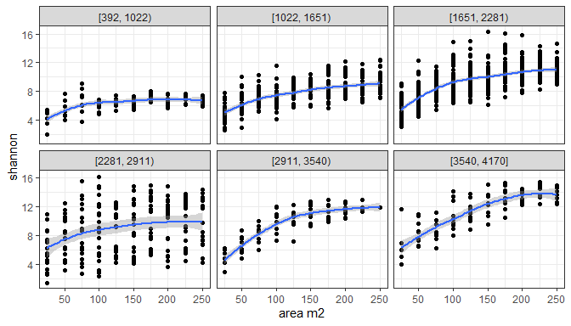

**Figure** **2:** Area vs beta and alpha diversity of vascular plants

On the other hand, the effect of the analysis scale on beta diversity will be negative, linearly decreasing beta diversity on a larger scale (Figure **3**). Similar to the above, the effect of the scale will be more pronounced at high elevations, and less at low elevations (Figure **4**). Thus, at high elevations, beta diversity will be rapidly reduced as the scale of analysis increases, while at low elevations such a decrease will occur to a lesser extent.

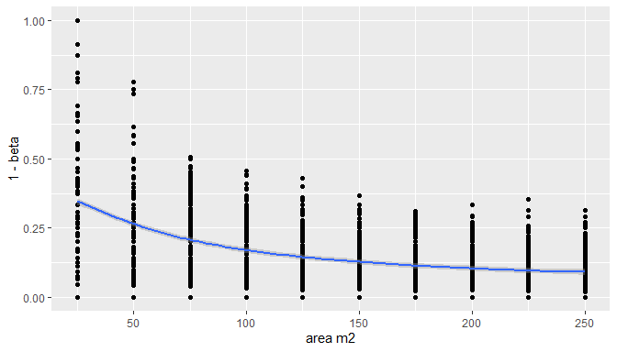

**Figure** **3:** Area vs beta and alpha diversity of vascular plants

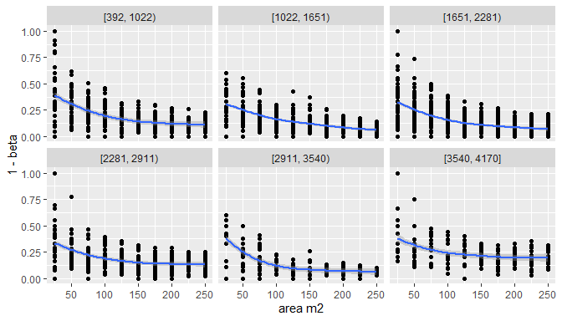

**Figure** **4:** Beta and alpha diversity of vascular plants

Such patterns could be due to the higher density of species at high elevations. In contrast, at low elevations, plant diversity tends to be more dispersed over a larger area, requiring more sampling effort to record total diversity. However, several covariates could interact in this relationship, in particular distance, temperature, humidity and rainfall. In relation to distance, this variable could distort the association between scale and diversity at different altitudes, a phenomenon known as spatial autocorrelation. Therefore, it is necessary to control this variable by grouping parcels into geographically distinct groups. The aforementioned environmental variables could be statistically controlled and included in the models. In the case of alpha diversity, average temperature is inversely related to alpha diversity in most altitudinal ranges, with the exception of the range 1000-1600 and 2200-2900 m. However, parcels of 7 to 10 aggregated parcels are more diverse overall (Figure **5**).

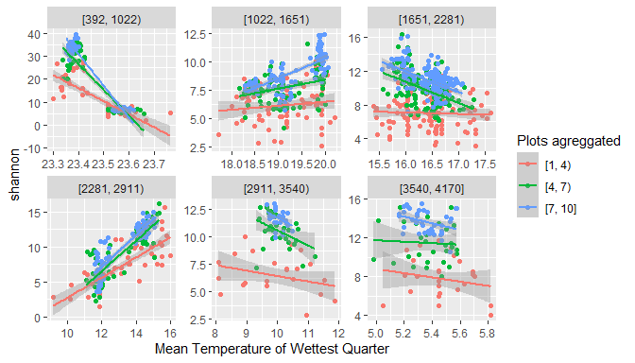

**Figure** **5:** Temperature vs alpha diversity of vascular plants

For example, the greater the absolute difference in the average temperature of the plots, the smaller the dissimilarity between plant communities in most altitudinal ranges (Figure **6**).

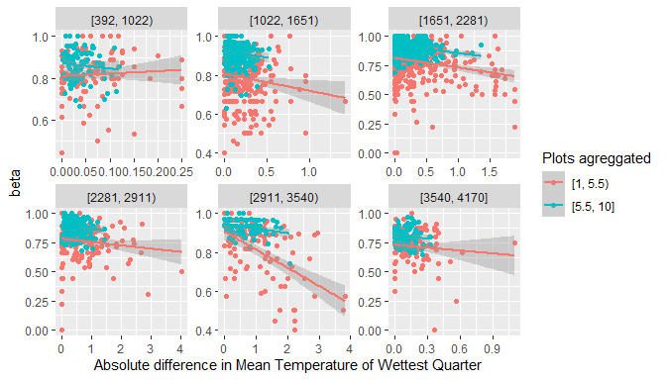

**Figure** **6:** Temperature vs beta diversity of vascular plants

# Schedule

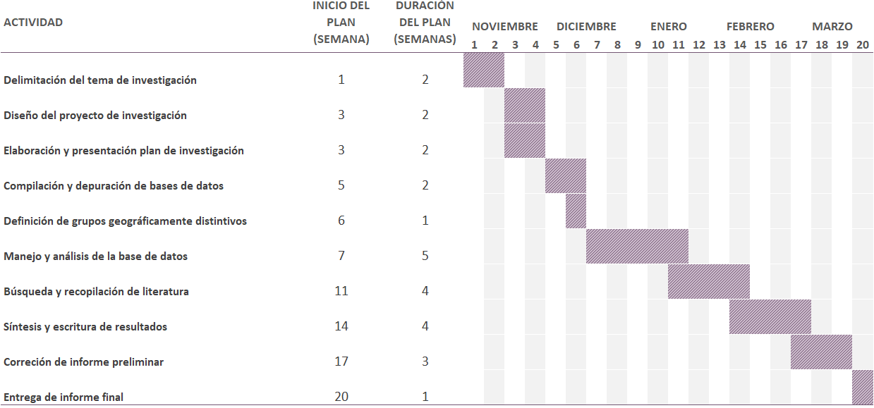

# Budget

| Item | UNIT VALUE | ITEMS | TOTAL VALUE |
| --- | --- | --- | --- |
| Laptop | 700 | 1 | 700 |
| Stationery supplies | 5 | 4 | 20 |
| Internet Service | 15 | 4 | 60 |
| Electricity Service | 15 | 4 | 60 |
| Mobilization Resources | 6 | 15 | 90 |
| Other | 20 | 4 | 80 |
|  |  | TOTAL | 1,010 |

# Literature Cited

Dell JE, Pokswinski SM, Richards LA, Hiers JK, Williams B, O'Brien JJ, Loudermilk EL, Hudak AT&Dyer LA. 2019 a. [Maximizing the monitoring of diversity for management activities: Additive partitioning of plant species diversity across a frequently burned ecosystem](https://doi.org/10.1016/j.foreco.2018.09.022). Forest Ecology and Management. 432(September 2018): 409-414.

Dell JE, Salcido DM, Lumpkin W, Richards LA, Pokswinski SM, Loudermilk EL, O'Brien JJ & Dyer LA. 2019 b. [Interaction Diversity Maintains Resiliency in a Frequently Disturbed Ecosystem](https://doi.org/10.3389/fevo.2019.00145). Frontiers in Ecology and Evolution. 7(May): 1-9.